**Sampling Techniques**

**Probabilistic Sampling:**

In **probabilistic sampling**, each member of the population has a **known and non-zero probability** of being selected in the sample. This allows for more objective, reliable inferences about the population, and makes it possible to calculate sampling errors.

**Key Features of Probabilistic Sampling:**

* **Randomness**: The selection process involves randomness, giving each unit of the population a known chance of selection.
* **Generalizability**: Results can be generalized to the entire population because of the random selection.
* **Sampling Error**: The sampling error can be estimated, allowing for confidence intervals and hypothesis testing.

Types:

1. Random Sampling - Every individual in the population has an equal chance of being selected.
2. Stratified - The population is divided into subgroups (strata) based on shared characteristics, and random samples are drawn from each subgroup.

Example: Dividing a population by age groups and randomly selecting people from each group.

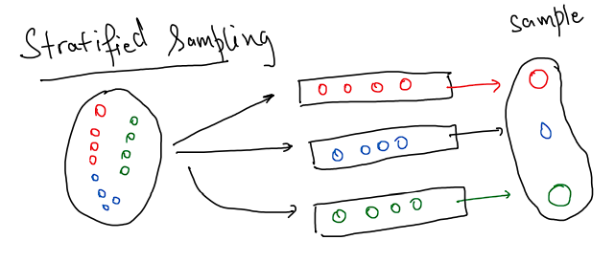

1. Clustered Sampling - The population is divided into clusters, and a random sample of clusters is selected. Then all individuals within the selected clusters are surveyed.

Example: Dividing a city into neighborhoods (clusters) and randomly selecting several neighborhoods to survey every household within.

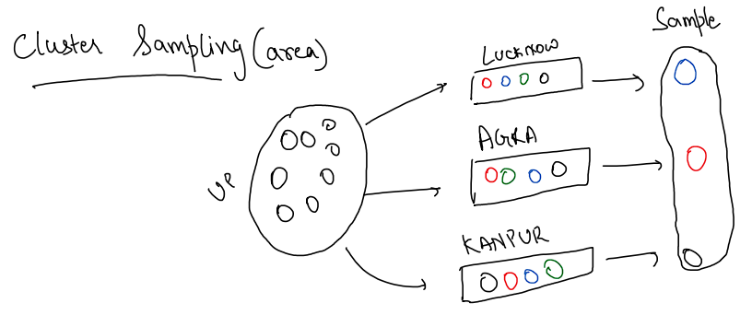

1. Systematic Sampling - Selects every k-th element from a list of the population, starting at a random point.

Example: Choosing every 10th person from a list of customers.

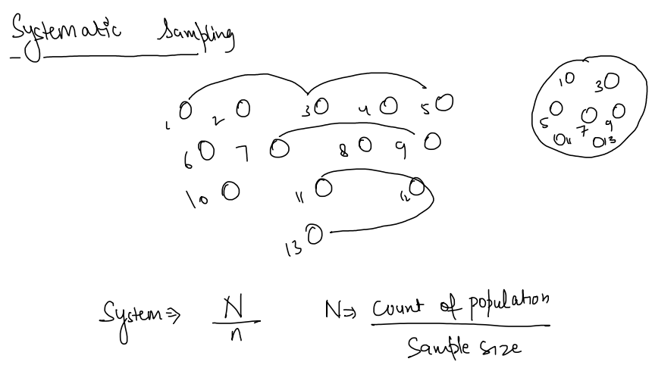

**Non-Probabilistic Sampling:**

In **non-probabilistic sampling**, some members of the population may have **no chance** of being selected, and selection is based on the subjective judgment of the researcher or other non-random methods. This makes it more difficult to generalize the results to the entire population.

**Key Features of Non-Probabilistic Sampling:**

* **Non-Random Selection**: The selection is based on factors like convenience, judgment, or referrals, rather than random chance.
* **Less Generalizable**: The results are often not generalizable to the entire population because not all members had a chance of being selected.
* **Sampling Error Unknown**: It’s not possible to estimate sampling error or calculate confidence intervals because the selection isn't random.

Types:

1. Convenience Sampling - The sample is selected based on ease of access and availability.

**Example**: Surveying people at a shopping mall because it's convenient.

1. Judgement - The researcher uses their expertise or judgment to select a sample that they believe is representative of the population.

Example: A researcher selecting key informants or experts in a specific field for a qualitative study.

1. Quota Sampling - The researcher selects a certain quota of subjects from various subgroups, but the selection within each subgroup is non-random.

Example: Interviewing 50 men and 50 women without randomizing the selection process.

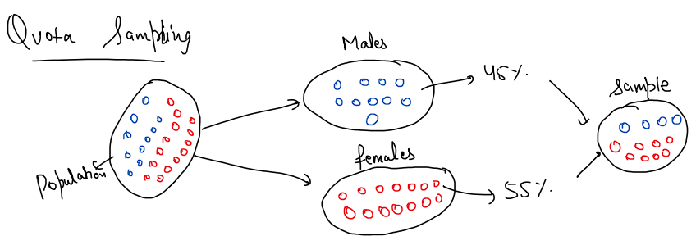

1. Snowball Sampling - Existing participants recruit future participants from their acquaintances.

Example: Studying a hard-to-reach population, such as drug users, where participants refer others they know.

